|  |  |
| --- | --- |
| documentation  This is a final project for second semester. |  |

Jenny’s

shop

TEAM MEMBERS

|  |  |
| --- | --- |
| STUDENT | MUHAMMAD TALHA |
| STUDENT | FAKHAR E ARJUMAND |
| STUDENT | SAFIULLAH |
| STUDENT | MAHEEN MANSOOR |
| STUDENT | MUHAMMAD MUNEEB |

PROJECT MENTOR: MISS ANNY JIBRAN

Contents

INTRODUCTION: 6

PROBLEM DEFINITION 7

CASE STUDY 7

SYPNOSIS 8

HARDWARE & SOFTWARE REQUIREMENT 8

SCOPE OF THE WORK 9

ARCHITECTURE AND DESIGN OF THE SYSTEM 10

SITEMAP 11

TASK SHEET 12

LIST OF VALIDATION 13

SUBMISSION CHECKLIST 14

SCREEN SHOTS 16

# Introduction:

The thirst for learning, upgrading technical skills and applying the concepts in real life environment at a fast pace is what the industry demands from IT professionals today. However busy work schedules, far-flung locations, unavailability of convenient time-slots pose as major barriers when it comes to applying the concepts into realism. And hence the need to look out for alternative means of implementation in the form of laddered approach.

The above truly pose as constraints especially for our students too! With their busy schedules, it is indeed difficult for our students to keep up with the genuine and constant need for integrated application which can be seen live especially so in the field of IT education where technology can change on the spur of a moment. *Well, technology does come to our rescue at such times!!*

Keeping the above in mind and in tune with our constant endeavour to use Technology in our training model, we at Aptech have thought of revolutionizing the way our students learn and implement the concepts using tools themselves by providing a *live and synchronous eProject learning environment!*

# PROBLEM DEFINITION

This Web portal will be a responsive and visually appealing Website to be used by individuals. This portal will be designed to provide shopping process by considering the various problems faced by the customer.

# CASE STUDY

Jenny is a doing business of cosmetics and imitation jewelry. She operates from home. Initially she started the entire activity by contacting the nearby friends and relatives, inform them about the various products available with her and their prices. Maria used to maintain the catalogue of products to display and diary for contacting the clients wherein she used to record their contact details and also to record their orders.

With the growing demands of the business and as the number of clients is increasing day by day, she wishes to have a web site with the complete product list for the user, also user should be able to place the order using the website.

Web site should also record the complete information regarding the client.

# sypnosis

The proposed solution is a Website titled JENNY’S SHOP. It should help individuals with online shopping for COSMETICS AND IMMITATED JEWELLERY at affordable prices

JENNY’S SHOP provides an easy shopping facility for COSMETICS AND IMMITATED JEWELLERY in excellent condition to the customers, wherein they can sit at one place and shop online anytime, anywhere 24/7.

# hardware & software requirement

# Hardware

* A minimum computer system that will help you access all the tools in the courses is a Pentium 166 or better
* 128 Megabytes of RAM or better

# Software

Technologies to be used:

* PHP
* MySQL
* PERL
* Apache

# SOFTWARE USED

* Visual Studio Code

# scope of the work

The user should be able to do the following:

1. Browse through the categories and products available and should be able to add products to the shopping basket.
2. User should be able to specify the quantity of the products required.
3. Complete / Finalize the order.
4. While ordering the product the user should input the following information:
   * Name
   * Address
   * E-mail
   * Work Phone No.
   * Cell No.
   * Date Of Birth
   * Category
   * Remarks(other additional informational)
5. The user should be able to search a product by name.

Administrator should be able to do the following:

1. Add/Delete categories and products into the website.

1. Update the information for the existing products.
2. Maintenance of the web site
3. Add / Delete records in database.
4. Backup the database.
5. Generate/View the report upon top 10 best selling products.
6. Generate/View the report upon top 10 clients/users (doing maximum shopping).

# architecture and design of the system

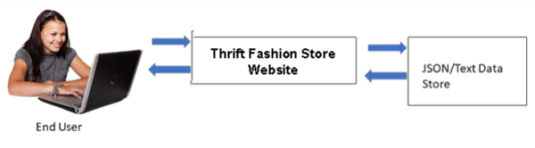

**JENNY’S SHOP**

MYSQL

# sitemap

JENNY’S SHOP

ADMIN

ABOUT

CONTACT

ORDERS

SHOP

HOME

ADMIN PANEL

PRODUCTS

# TASK SHEET

|  |  |  |  |  |
| --- | --- | --- | --- | --- |
| *s.no* | *task* | *Actual start day* | *When completed* | *status* |
| 01. | Case study | 6 DEC | 8 DEC | COMPLETED |
| 02. | Material searching | 8 DEC | 12 DEC | COMPLETED |
| 03. | Graphics  designing | 12 DEC | 15 DEC | COMPLETED |
| 04. | development | 15 DEC | 20 DEC | COMPLETED |
| 05. | testing | 21 DEC | 23 DEC | COMPLETED |
| 06. | documentation | 24 DEC | 25 DEC | COMPLETED |

# LIST OF VALIDATION

Some sample validation as follows:

|  |  |
| --- | --- |
| OPTION | VALIDATED |
| Do all text links to the appropriate web pages? | Yes |
| Do all images links to the appropriate web pages? | Yes |
| Are all the images and links clearly visible on the page? | Yes |
| Is the web page opening properly in all the tested web browsers? | Yes |
| Are the animations loading well? | Yes |
| Is the web page taking too long to load? | Yes |
| Is the navigation sequences correct through all the web pages on the site? | Yes |
| Is the web page responsive? | Yes |
| Is the JavaScript coding working as expected in all click events? | Yes |

# submission checklist

|  |  |  |  |  |
| --- | --- | --- | --- | --- |
| *s.no* | *List of items* | *yes* | *no* | *comments* |
| 1 | Are all users able to view images and links? | Yes |  |  |
| 2 | Have all composites of the website been integrated and do they load as expected? | Yes |  |  |
| 3 | Are the GUI content devoid of spelling mistake? | Yes |  |  |
| 4 | Is the portal user friendly? | Yes |  |  |
| 5 | Is the website launching correctly in the browser? | Yes |  |  |

# Screen shots

USER HEADER/NAVBAR





ADMIN HEADER/NAVBAR

ABOUT US PAGE

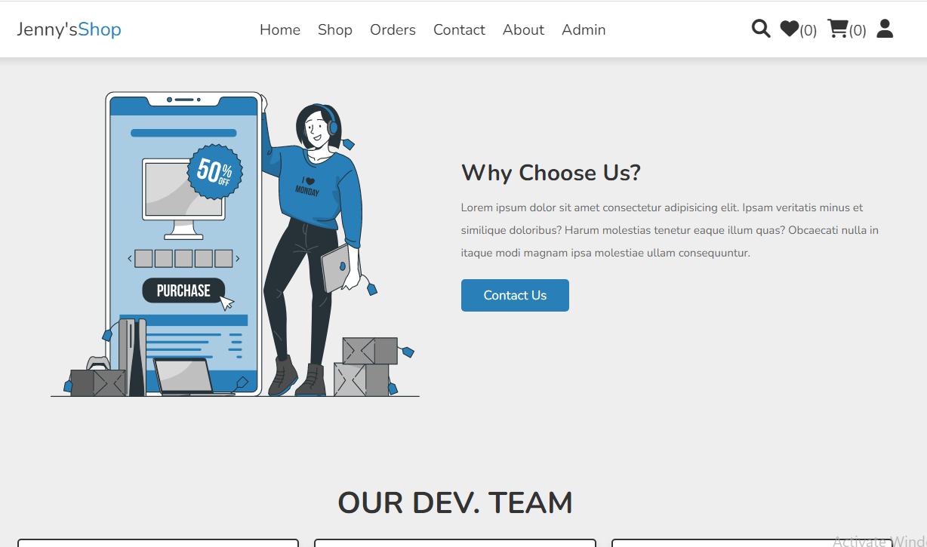



MAIN PAGE

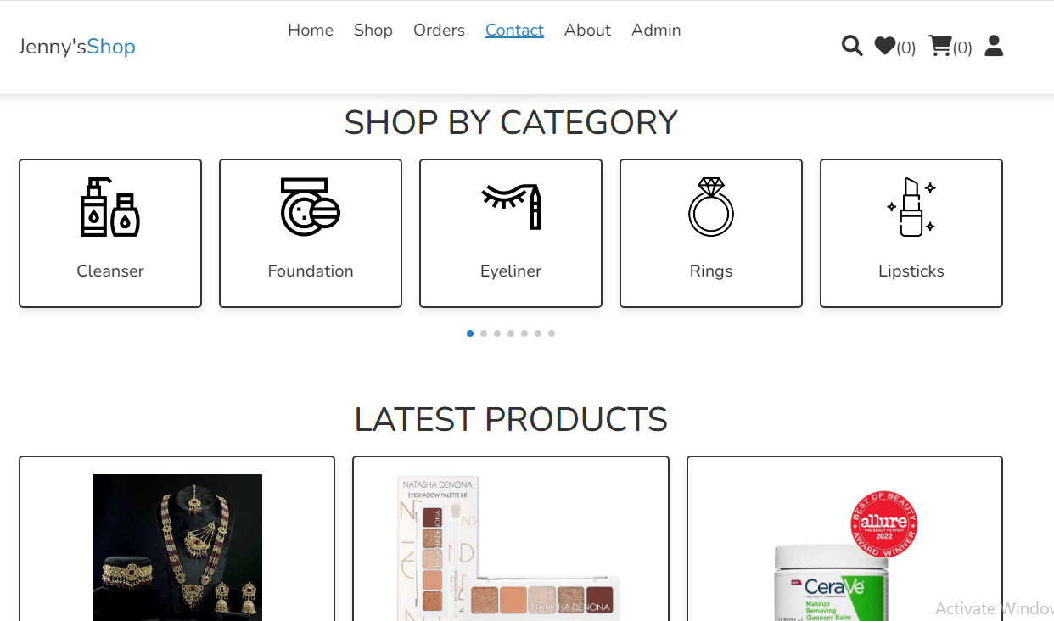

GALLERY PAGE

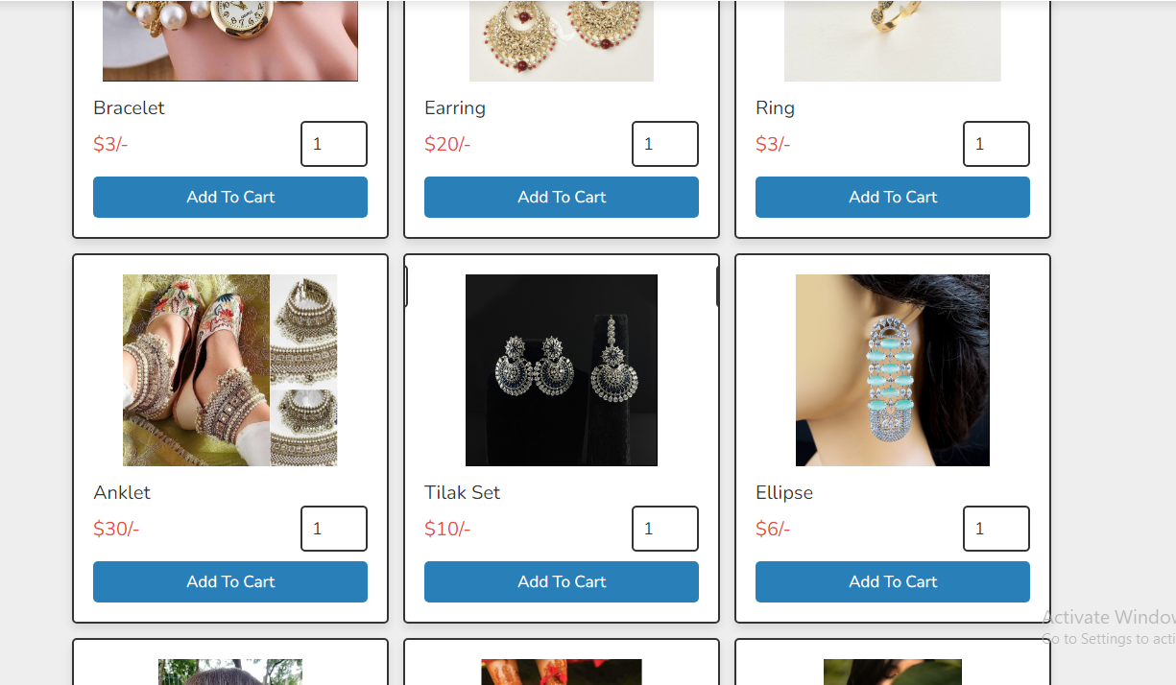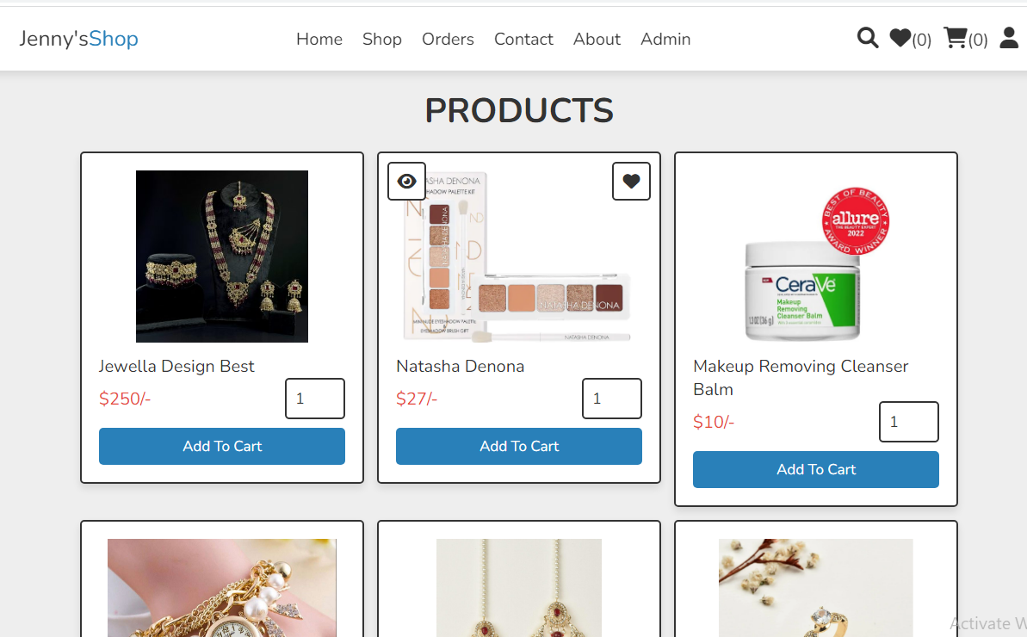

RELATED TOPICS

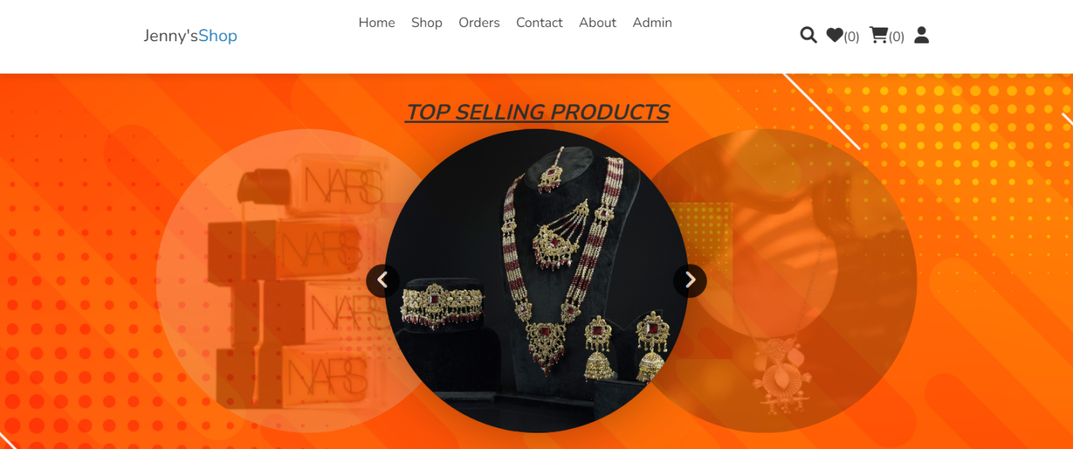

CONTACT US

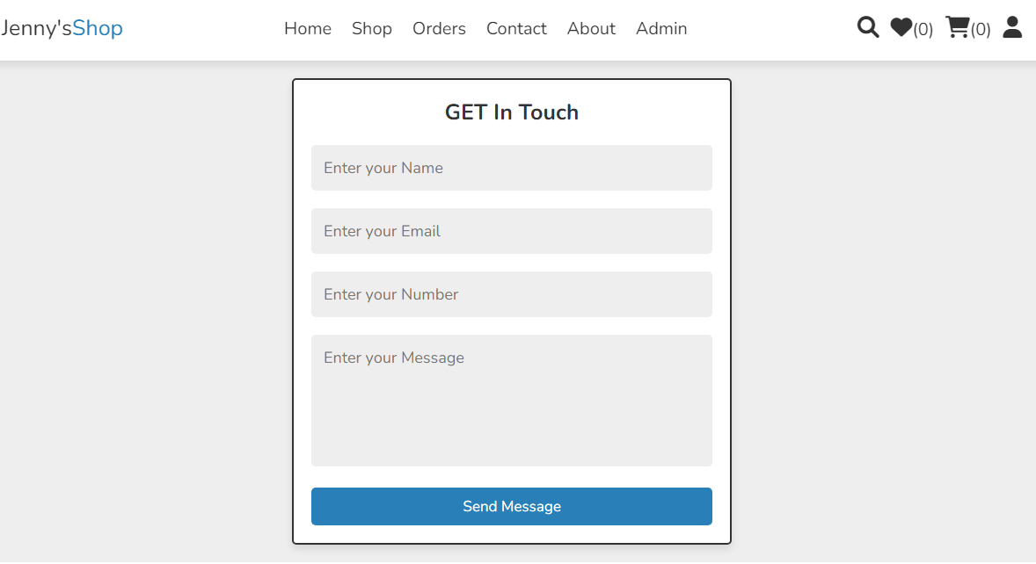

TOP 10 PRODUCTS/CUSTOMERS

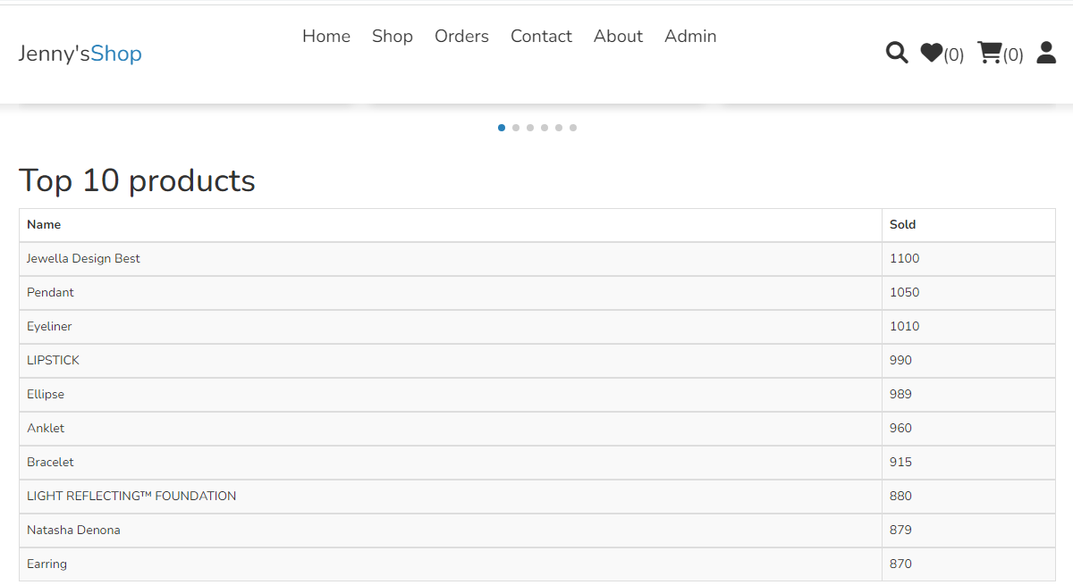

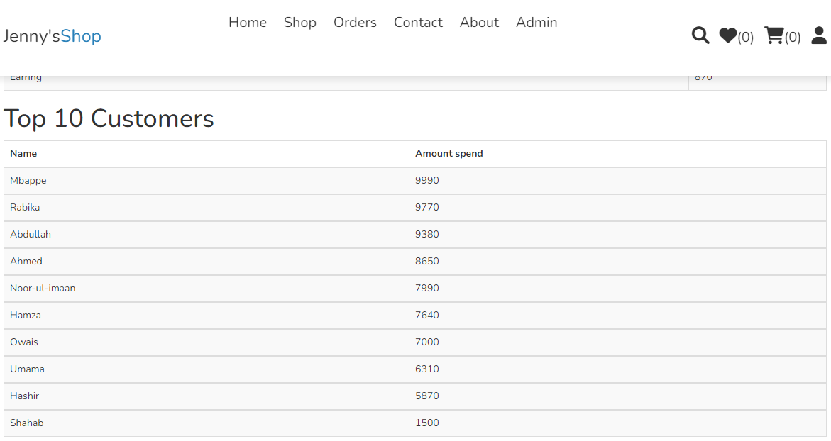

ADMIN PANEL

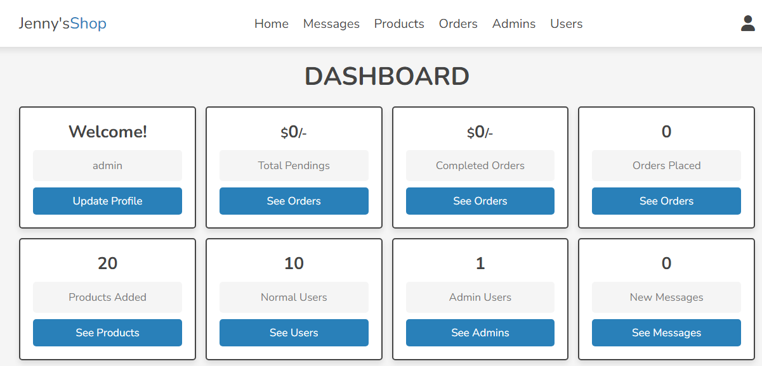

FOOTER

